**Setup a Meta Ads Campaign for Jio Mart – Catalogue**

**Objectives:**

1. To set up a Meta (Facebook & Instagram) Ads Campaign for Jio Mart using a Catalogue as the primary ad format.
2. To define and justify the campaign objective that aligns with Jio Mart’s business goals, ensuring the ad drives the right actions.
3. To establish performance goals, target locations, and budget allocation, ensuring the campaign reaches the right audience and delivers measurable results.
4. To determine the best ad placements, audience targeting (age, gender, interests), and optimization strategy for maximizing engagement and conversions.
5. To design a product catalogue with at least 5-10 Jio Mart products, ensuring a visually appealing and structured product display.
6. To create compelling ad creatives with a strong headline, primary text, CTA (Call-to-Action), and high-quality visuals to attract potential buyers.

**-By Aishwarya N**

**Campaign Objective: Sales (Conversions)**

I have chosen the **Sales (Conversions)** objective for this campaign because Jio Mart’s primary goal is to drive online purchases and increase revenue. This objective focuses on reaching users who are most likely to complete a purchase, optimizing the campaign to target high-intent customers. The **Catalogue** ad format works perfectly for this objective, as it allows users to browse and shop from a variety of products directly within the ad, reducing the steps needed to make a purchase. Additionally, I selected the **Website** as the destination because Jio Mart’s e-commerce platform is where customers can complete their transactions, making it the ideal place to direct users for conversions and ensuring a seamless shopping experience.

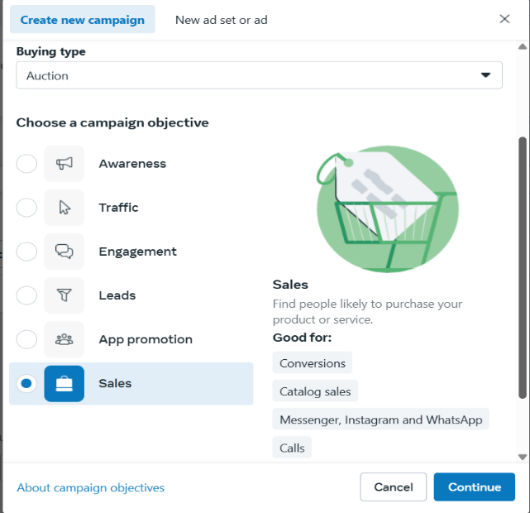 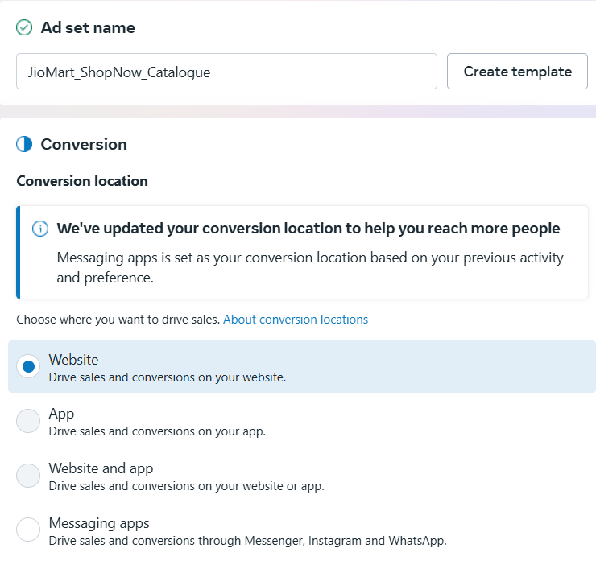

**Performance Goal and Budget**

For this campaign, I have chosen "Maximize Number of Conversions" as the Performance Goal because Jio Mart’s primary objective is to drive as many purchases as possible. By optimizing for conversions, the campaign will target users who are more likely to complete a purchase, ensuring that the budget is spent efficiently.

For the budget, I have selected a daily budget of ₹200 for 7 days, making the total campaign budget ₹1,400. This budget is suitable for testing the effectiveness of the campaign while maintaining cost efficiency. A daily budget ensures that the campaign remains active throughout the week, allowing Jio Mart to reach a wider audience over time. Since Meta’s ad system optimizes for conversions based on real-time performance, a daily budget helps in gradually improving ad delivery, leading to better results. This budget strategy aligns with Jio Mart’s business goal of increasing online orders while keeping ad spending optimized for maximum conversions. By analysing the campaign’s performance adjustments can be made for future campaigns to improve efficiency.

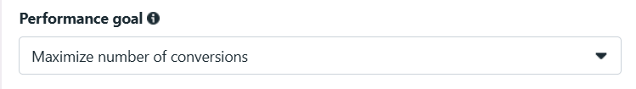 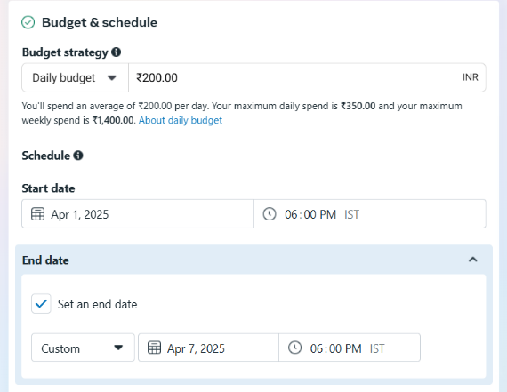

**Location, Targeting, Placements**

For this campaign, I have selected Delhi, Ahmadabad, Pune, Maharashtra, Bangalore, Tamil Nadu, Hyderabad Telanganaas the target locations because these areas have a high demand for online grocery and household shopping. Targeting these locations ensures that Jio Mart reaches potential buyers who are more likely to engage with the ad and make a purchase.

The **target audience** for this campaign includes individuals aged [18-60], who are interested in online grocery shopping, household essentials, and personal care products. This audience is chosen based on consumer behaviour insights.

For ad placements, I have selected Facebook Feed, InstagramFeed and Stories, as these are the most engaging platforms where users actively browse and interact with shopping-related content.

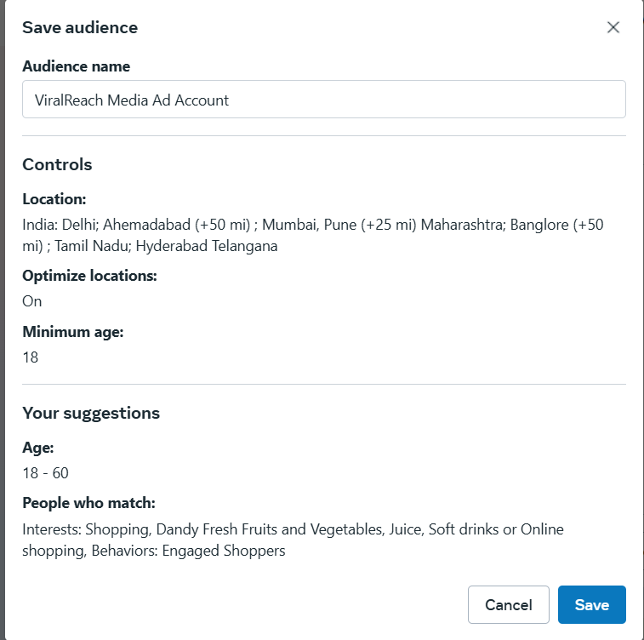

**Catalogue Design**

The Jio Mart Catalogue is designed to showcase a variety of products, including groceries, household essentials, and personal care items. Each product in the catalogue includes a high-quality image,product name, price, and description, making it easy for users to browse and select items.

The catalogue is structured in a way that allows users to scrollthrough multiple products within the ad, ensuring a seamless shopping experience. This format increases engagement and encourages potential buyers to explore different product options before making a purchase.

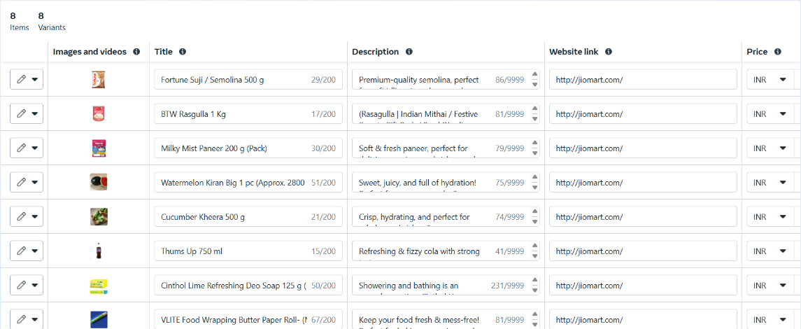

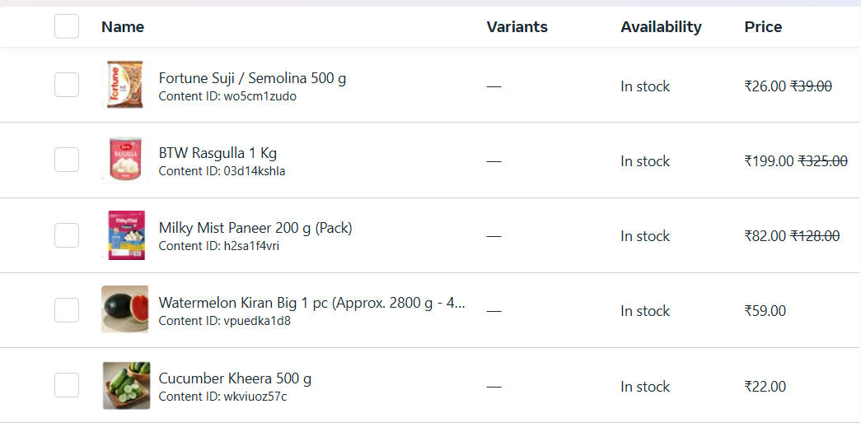

**Ad Creative Design**

1. **Headline:** Shop Groceries & More at Jio Mart
2. **Primary Text:** Find fresh groceries, electronics, and household essentials at unbeatable prices! Fast delivery and amazing deals!
3. **Call-to-Action (CTA):** Shop Now

The **CTA button** is designed to drive users directly to the Jio Mart website, where they can explore more products and complete their purchase. This ensures a smooth transition from ad engagement to conversion, aligning with the campaign’s goal of maximizing sales.

